 | 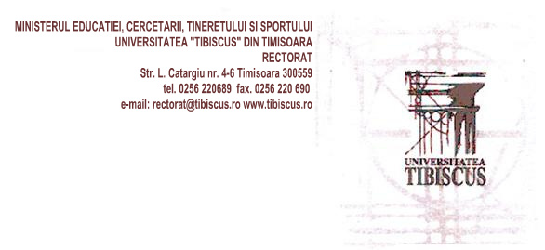
REGISTRATION FORM for Grundtvig Workshop
“LITERACY EDUCATION IN PRISON: POLICIES, PRACTICES, ETHNOGRAFIES OF A ‘THIRD SPACE’”
Romania (Timișoara), November 18-23.2013

Please fill in all the fields included in this registration form and send it by email
before October 27st 2013 to alina_zamosteanu@yahoo.com.
Selection results will be announced on 1st of November.
All applicants will be informed about the selection results.

Personal information

Name
Surname
Sex (male/female)
E-mail (private)
Telephone
Organisation
Name
Website
Your position in the organisation
Other information
Special requirements
(special diets, e.g. vegetarian etc.)

Questionnaire
Describe your motivation for participating in this workshop
Describe your previous involvement in literacy projects/programs
Describe your interest in prison education
Describe how you expect this workshop to improve your work
Name one literacy education aspect you need to master better after workshop
Describe how you will disseminate the results of the workshop

